|  |  |
| --- | --- |
| <form>  **Name** <input **type**=”**text**”><br>  <input **type**=”**radio**”><br>  <input **type**=”**checkbox**”><br>  <textarea></textarea><br>  <input **type**=”**button**” value = “**go!**”><br>  <input **type**=”**submit**”>    </form> |  |

**LABEL**

<label id="lb1">Profile Type:&nbsp;&nbsp;</label>

**TEXTBOX**

<form action="demo_form.asp">  
  First name: <input type="text" name="fname"><br>  
  Last name: <input type="text" name="lname"><br>  
  <input type="submit" value="Submit">  
</form>

**DATE PICKER**

<input type="date" id ="aa" />

**BOTON**

<input id='BtnUnlock2' type="button" onclick="Check2(); return false;"

style="width:83px;height:31px; color: black; font: bold 17px Arial" value='UNLOCK'/>

**LI**

<ul>

<li><a href="http://w3.org">The W3C</a>

<li><a href="http://w2.org">The W2C</a>

<li>otros

</ul>

**DROPDOWN**

<select id="dpType" onchange="GetText();" style="color:Black;width:130px;">

<option value="0">Select One</option>

<option value="1">Trained Skills</option>

<option value="2">Default Skills</option>

</select>

<script type="text/javascript">

        function GetText() {

            var e = document.getElementById("dpType");

            var valor = e.options[e.selectedIndex].value;

            var texto = e.options[e.selectedIndex].innerText;

            document.getElementById('Hidden1').value = texto;

        }

C#

string valor = Hidden1.val();

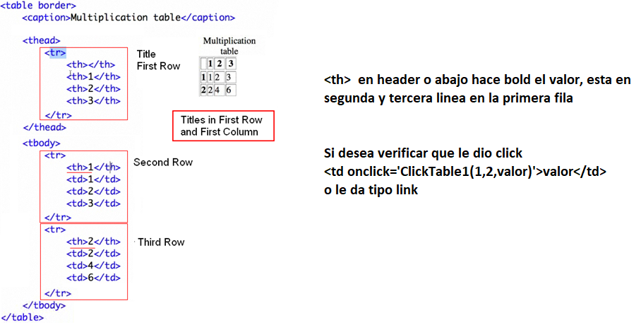

Image with tooltip



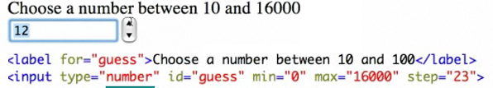

<input type="number" id="minutos" min="0" max="6" onchange="SetMinutos();"/>

function SetMinutos() {

var valor = document.getElementById("minutos").value;

document.getElementById('hdMinutos').value = valor;

return false;

}

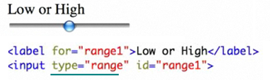

Upload



**HIDDEN FIELD**

<input type="**hidden**" id="Language" value="English">

$("#Language").val("Spanish,English,French");

var listaStr = $('#Language').val();

var Lista = eval(listaStr);

var temp = new Array();

temp = listaStr.split(",");

alert(temp[1]);